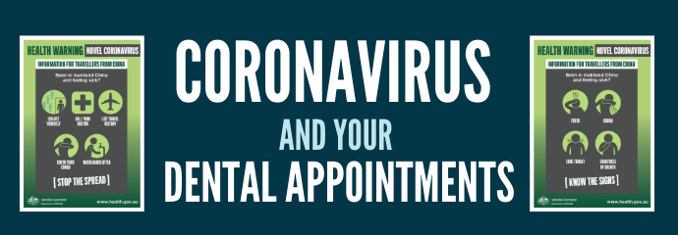
To all our Valued Patients:
At <Practice Name>, we are committed to doing our part in minimizing the spread of the Coronavirus, COVID19. As health care professionals, we must follow well-researched, scientific public health advice to help limit infections and slow the spread of COVID-19. In an effort to preserve the limited supply of personal protective equipment available for emergency dental care and frontline health care personnel dealing with the virus, we will be rescheduling all appointments for non-urgent dental care for the next 14 days.
Rest assured that we are available for emergency treatment and will continue to follow all CDC recommendations regarding sterilization of instruments, surfaces and workspaces to protect our patients and staff members.
We encourage everyone in our community to take steps to minimize the spread of the virus as dictated by the CDC. Emerging information regarding this virus is dynamic and updated regularly. The most reliable source of information and newest recommendations are found here: https://www.cdc.gov/coronavirus/2019-ncov/.
If you have a question about an upcoming appointment, please contact us. Stay safe out there!

