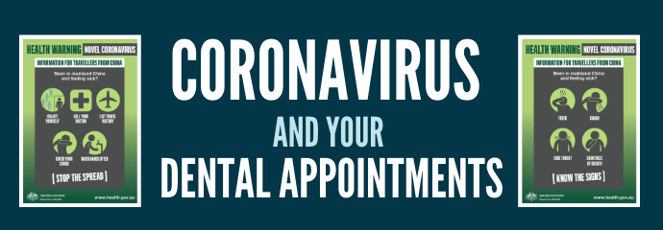
Jeffrey,

Due to the COVID-19 virus and for the safety of our patients and staff, our office will be closed effective {March 18, 2020 through April xx, 2020.} This decision was made based on the recommendations of the American Dental Association, the CDC, and our commitment as healthcare providers to help reduce the spread with-in our community.

We will still be seeing patients for emergency and limited care services only. If you do have a dental emergency, please call our office to schedule an appointment at {(xxx)xxx-xxxx}
If you do have a scheduled emergency or limited care visit with our office, we are asking you to please follow the steps below:

- Upon Arrival, please remain in your car and text or call our office to let us know you are here at (xxx) xxx-xxxx. Our front office team will call you and have you enter the building when we are ready for your visit.
- Please sanitize your hands upon check in.
- Notify staff before your appointment if you have a cough or fever. We will need to reschedule your appointment if this is the case.

Our team is also available to answer any questions. . Thank you to everyone for your understanding and patience.

