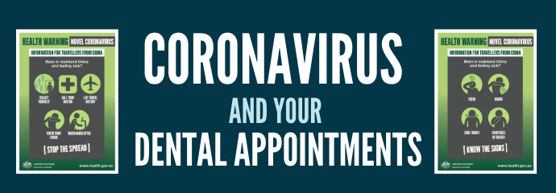

Dana,
At <Practice Name>, we are committed to doing our part in minimizing the spread of the Coronavirus, COVID-19. At this time, we are following the CDC’s request to delay all non-emergency dental care in order to preserve limited supplies of protective equipment for emergency dental care and frontline health care personnel. Please call our office to reschedule your appointment. Should you have a dental emergency, please call the office for an appointment. Let’s work together to keep everyone safe and healthy!
You can follow current CDC updates here: https://www.cdc.gov/cornoavirus/201-9nCov/index.html

